Creating a Virtual Reality Meeting Room Using Unity Relay and Vivox
Harsh Lalwani , Gurnoor Singh , Hemant Jindal , Tanish Singla Thapar Institute of Engineering and Technology in Patiala , 147004 , Punjab gsingh13_be23@thapar.edu

Abstract - The creation of a virtual reality (VR) meeting room utilizing Unity VR, Unity Relay, and Vivox 3D audio is presented in this article. The objective is to develop a more captivating and immersive 3D meeting experience, going beyond standard 2D video conferences. VR headsets allow users to enter the virtual space, engage with tools like whiteboards, sticky notes, and presentation screens, and converse using realistic spatial audio. Through a relay-based network that guarantees steady, low-latency connections, the system facilitates multi-user communication. The system's architecture, design methodology, interface techniques, and performance are all explained in this paper. The configuration offers seamless communication, good usability, and a productive atmosphere for remote collaboration, according to the results. All things considered, the VR Meeting Room shows how virtual environments can enhance remote work and communication.
Keywords- Unity;Relay;Vivox
- Introduction
Technical collaboration, academic work, and professional work now heavily rely on remote communication. However, the majority of conventional 2D video-conferencing platforms continue to seem constrictive; they hinder people's ability to communicate organically, diminish their sensation of presence, and frequently lead to exhaustion during extended sessions. Because everything takes place on flat screens, users have trouble with engagement, depth perception, and general situational awareness, which reduces the effectiveness of teamwork compared to real-world situations..
By immersing users in immersive 3D environments where communication feels more natural, virtual reality offers a possible substitute. Participants engage with customisable avatars, spatial 3D audio, and shared virtual tools that mimic real-world items rather than gazing at a grid of faces. Unity VR for realistic graphics, Unity Relay for dependable and seamless networking, and Vivox for realistic positional audio are used in the construction of our VR Meeting Room system. When combined, these technologies provide a secure, low-latency, and stable platform that can support multi-user sessions without the typical constraints of video conversations.
This project's main goal is to provide a virtual meeting space that facilitates intuitive collaboration, real-time communication, and a strong sensation of presence. The solution solves many of the drawbacks of conventional communication tools and shows how immersive technology may improve the efficiency, humanity, and engagement of distant collaboration by simulating an actual meeting space inside virtual reality.

Related Work
Virtual collaboration in VR and metaverse-style environments has been the subject of several studies and commercial platforms. Users can gather in common virtual areas and communicate via avatars using well-known platforms like Mozilla Hubs, Meta Horizon Workrooms, and Spatial.io. These platforms show how VR can improve remote communication, but they also have a number of disadvantages. Many have restricted mobility, need powerful VR hardware, or have difficult setup processes that make them less accessible. Another persistent problem is network stability, with certain platforms finding it difficult to sustain steady performance during multi-user sessions.
Academic research has concurrently investigated web-based VR transmission, motion tracking, and gesture detection. Real-time gesture detection, full-body tracking, and lightweight browser-based virtual reality experiences have all been made possible by technologies like MediaPipe, OpenCV, and Unity Render Streaming. Although these developments are encouraging, many of these systems are still unable to guarantee synchronized, safe, and seamless multi-user communication, particularly when using the public internet.
Our approach addresses the practical shortcomings of previous research while building on its merits. We develop a VR meeting environment that is lightweight and accessible without sacrificing performance by combining Unity Relay for reliable and NAT-friendly connectivity, Vivox for excellent spatialized audio, and Unity VR for optimal rendering and interaction. In comparison to previous VR conferencing technologies, this combination offers dependable low-latency communication, realistic audio presence, and customizable user engagement.

Methodology and System Design
The system architecture contains three main layers:
1. Unity VR Client: Everything the user sees and engages with within the virtual environment is managed by this layer. It creates a 3D meeting space, controls avatar mobility, and facilitates comfortable teleportation and seamless movement. In addition to selecting meeting spaces and interacting with items like whiteboards and presentation screens, users can personalize their avatars. This is basically the front-end that makes the virtual reality experience come to life.
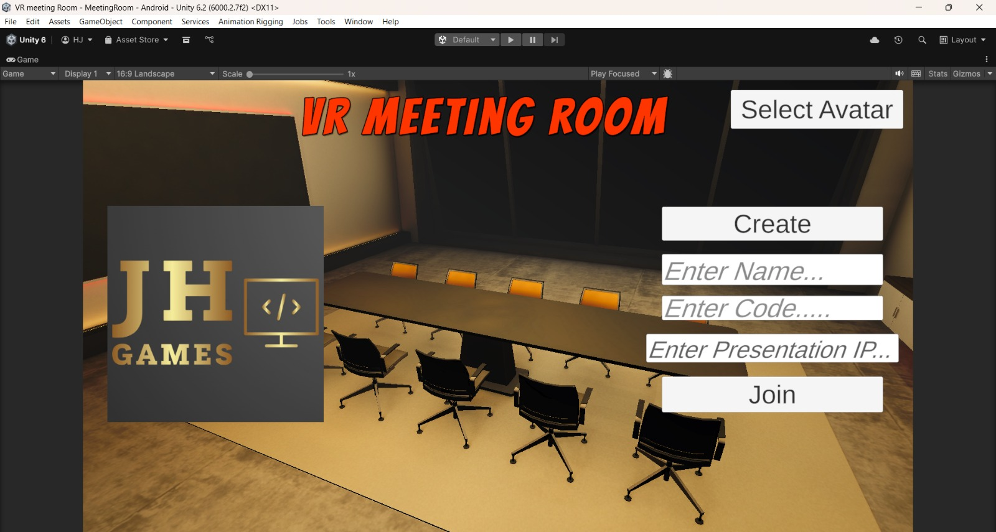
2. Relay Networking Layer: Unity Relay, which controls networking, guarantees that all users can connect safely without worrying about port forwarding or peer-to-peer compatibility. All participants' activities, including avatar locations, gestures, and shared objects, are synchronized in real time using Netcode for GameObjects. Even when several users are interacting at once, this layer maintains consistency in everyone's experience.
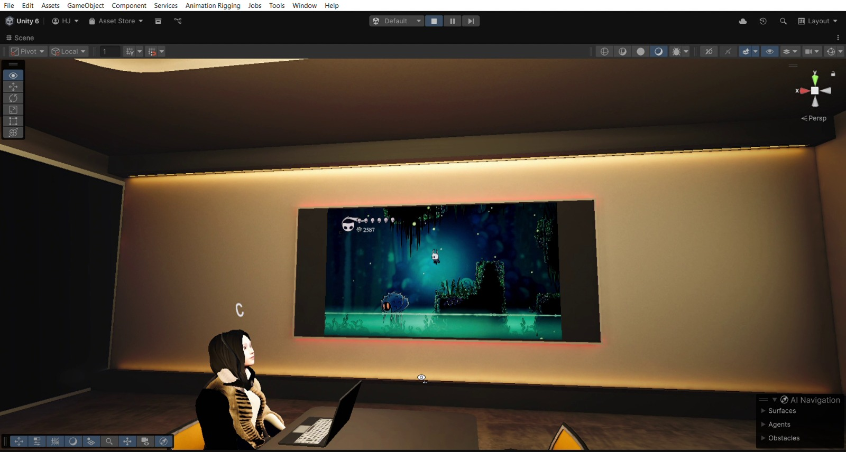
3. Voice & AI Layer: Vivox offers excellent spatial 3D voice chat for communication, enabling users to hear others according to where they are in the virtual space. Conversations become more organic and engaging as a result. In addition, a Python-based backend is utilized for simulations and serves as a basis for upcoming AI-driven capabilities including intelligent help, automated meeting tools, and gesture augmentation.
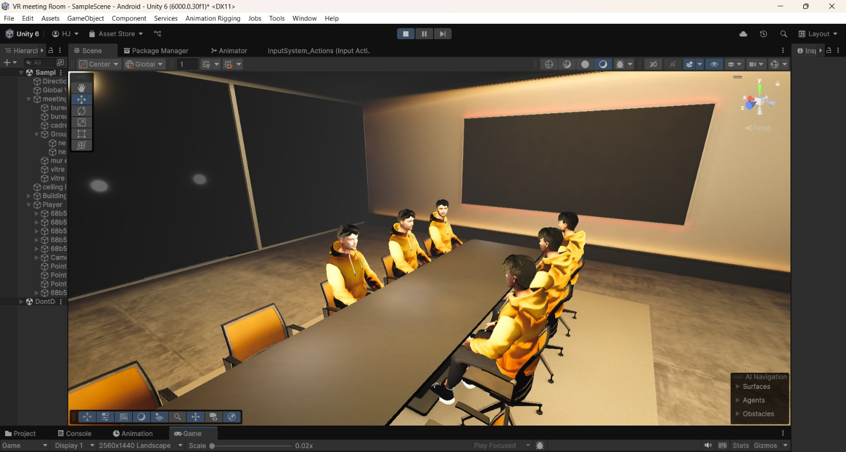
CollaborationTools:
The system also includes built-in tools to support teamwork. A shared whiteboard allows participants to draw or write together, sticky notes help with idea brainstorming, and a virtual presentation display enables screen sharing for slides or documents. These tools make the VR meeting room suitable for discussions, teaching, and project collaboration.
The architecture is designed to meet strict performance requirements. It maintains voice latency below 500 ms and keeps synchronization delays under 150 ms, ensuring real-time interaction. The system can support around 10 active users at once without any noticeable drop in quality, providing a smooth and reliable meeting experience.
- Results
The system operates dependably in actual multi-user environments, according to prototype testing. The spatial audio engine reliably produced clear and precise directional sound during testing involving several participants, making it simple for users to determine who was speaking and from where. Additionally, even when users were connected at varying network speeds, avatar movement and gesture synchronization remained seamless. No participant encountered significant delays or desynchronization because to the networking layer's adept handling of these variances.
Additionally, room formation times were effective, averaging less than five seconds from start to complete session setup. Strong responsiveness was demonstrated via collaboration tools including the shared whiteboard, sticky notes, and presentation screen; updates appeared virtually instantaneously on all linked devices, maintaining the flow of conversation during group discussions.
Stress testing provided additional evidence of the system's resilience. The Relay networking layer continued to operate steadily and with little packet loss even under high demand. This proved that the platform can facilitate multi-user communication at the same time without sacrificing interaction quality or dependability.

Future Work

To extend system capabilities, the following improvements are planned:

AI-Powered Meeting Intelligence:
The integration of automated note-taking and AI-driven meeting summaries is a crucial area for future development. The system will be able to track talks in real time, identify significant decisions, extract key points, and provide a polished meeting summary without human intervention by fusing speech-to-text, natural language processing, and subject detection. This improvement attempts to lessen participants' cognitive strain and guarantee that no important information is missed.

Better Tracking of Motion and Expression:
The technology will use sophisticated full-body tracking via sensors or MediaPipe-based vision models to produce a more expressive and lifelike virtual presence. This will enable VR to precisely replicate users' physical motions. In order to make avatars feel much more realistic and relatable during conversations, facial expression mapping is also intended to catch subtle emotional indicators like smiles or eyebrow movements.

Improved Interaction Through Gestures:
Enabling more natural interactions through gesture-based control is the focus of another planned enhancement. Without largely depending on controllers, users will be able to work together on shared tools, traverse menus, and handle virtual objects with their hands alone, resulting in a more fluid and natural form of engagement.
Decentralized and Secure Identity Management
The system will investigate blockchain-based identity management to improve trust and data security. This would guarantee users' digital identities are safe, verifiable, and unchangeable across various virtual environments. Long-term scalability across linked settings is supported and security is improved by such an approach.

Conclusion
A fascinating transition from conventional video conferencing to a more immersive and captivating mode of distant communication is demonstrated by the VR Meeting Room. By integrating Unity VR’s rich 3D interaction capabilities with the robust networking offered by Unity Relay and the realism of Vivox spatial audio, the system successfully generates a virtual world where players can speak and cooperate as if they were physically present together. The technology demonstrated steady performance during prototype testing, sustaining low latency and seamless synchronization even with numerous active users. A more organic and engaging meeting experience was made possible by features like shared whiteboards, sticky notes, and customisable avatars.
Participants reported increased interest, less weariness, and an overall sense of presence that is frequently lacking in typical video chats, which further supported the system's efficacy. These findings demonstrate how immersive technologies can improve team discussions, distant work, virtual classrooms, and cooperative problem-solving. The project establishes the foundation for upcoming improvements, such as AI-driven automation, more device support, and more expressive avatar systems, in addition to confirming the viability of VR-based conferencing. This VR Meeting Room is a first step toward the next generation of communication platforms created for the changing digital world, as virtual collaboration continues to gain relevance.
- References

[1] Unity Technologies, “Unity Documentation – VR Development,” 2025. [Online]. Available: https://docs.unity.com
[2] Unity Technologies, “Netcode for GameObjects: Multiplayer Networking Guide,” 2025. [Online]. Available: https://docs.unity.com/ugs
[3] Unity Technologies, “Unity Relay Manual – Secure Multiplayer Connectivity,” 2025. [Online]. Available: https://docs.unity.com/relay
[4] Unity Technologies, “Vivox for Unity – Spatial Audio Communication,” 2025. [Online]. Available: https://docs.unity.com/vivox
[5] R. Azuma, “A Survey of Augmented Reality,” Presence, vol. 6, no. 4, pp. 355–385, 1997.
[6] J. Jerald, The VR Book: Human-Centered Design for Virtual Reality. ACM Press, 2015.
[7] P. Milgram and F. Kishino, “A Taxonomy of Mixed Reality Visual Displays,” IEICE Transactions on Information Systems, vol. 77, no. 12, pp. 1321–1329, 1994.
[8] Google Research, “MediaPipe: ML Solutions for Real-Time Motion Tracking,” 2023. [Online]. Available: https://google.github.io/mediapipe
[9] G. Salvendy, Handbook of Human Factors and Ergonomics, 4th ed. Wiley, 2012.
[10] S. M. LaValle, Virtual Reality. Cambridge University Press, 2017.
[11] B. R. Barricelli, “Human-Virtual Agent Interaction: A Survey,” Computers & Graphics, vol. 76, 2018.
[12] Meta Platforms Inc., “Horizon Workrooms – VR Collaboration Platform,” 2024. [Online]. Available: https://www.oculus.com/workrooms
[13] Mozilla, “Mozilla Hubs: Open Source Social VR Platform,” 2024. [Online]. Available: https://huns.mozilla.com

